Lab report 8: 2023/05/23

* In this task, first I read all the images containing a chessboard pattern, in the provided path.
* Then using the cv::findChessboardCorners() function, I detected the chessboard intersections of each image and then cv::cornerSubPix() function to refine the detections and get the float value of the intersection location.
* After that I used cv::calibrateCamera() function with the result points in the previous step to calibrate the camera.
* Then I computed the reprojection error, camera matrix, distortion coefficients, and mean reprojection error of the camera. For calculating the mean reprojection error I used this algorithm: sum of (norm of image_points and projected_points) divided by the number of points.
* Finally, I used the parameters of the camera calculated in previous steps to undistort and rectify a new test image taken by the same camera, and showed both the original and result image in the same window.

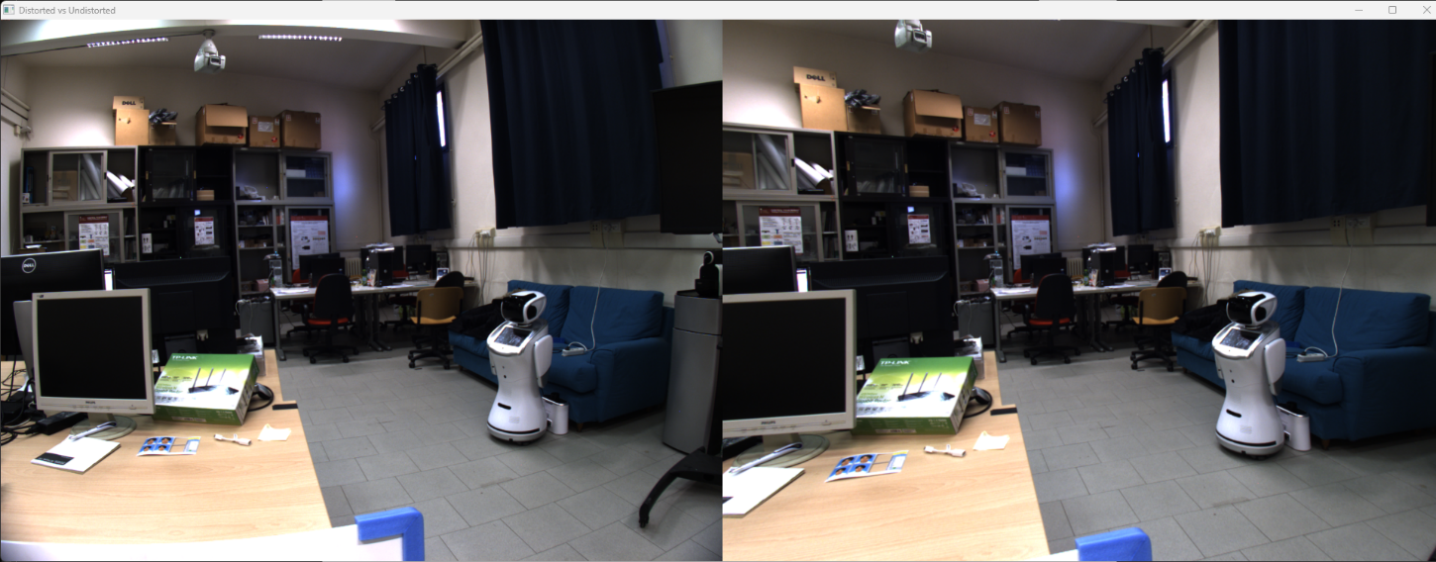

Figure - Original images vs Undistorted images

